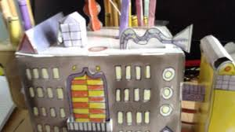
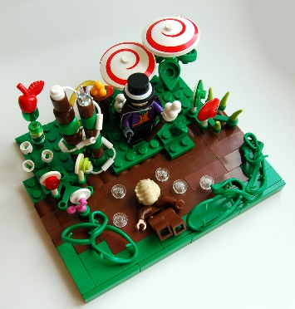

Year 3 Autumn Term 1 Creative Homework

This half term we are learning about Chocolate. For our optional homework, could you create your own Chocolate Factory?
This could be a drawing, a 3D model, a plan of the inside of your chocolate factory. This is your time to be creative and is entirely your choice how you present it to the class. I have given you some ideas for inspiration.
During this half term, if you have any chocolate wrappers or facts you would like to share with the class, please bring them in, as there will be opportunities to do this.
When you have completed your homework, please bring this into school and we will share it with the class.
Myself and Mrs Watts are looking forward to seeing your creations.

Miss Whatmough
