**School App**

Please ensure that you are signed up to the school app as much of our communication will be through this.

**Spellings**

The children will learn words from the Rainbow Spelling Scheme. Please help your child to learn these at home for a test each Monday.

You may find the Squeebles Spelling Test App helpful.

Please also check that your child understands the meaning of each word.

**The following is what is needed each day**

**Mondays**

Bring book bags with reading books- reading books checked and changed

Celebration Worship - bring certificates / medals /trophies

Spelling test - new spellings are also given out

Bring Tiny Turtle back to

school

Bring PE Kits. Please ensure hair is tied up and earrings are removed.

**Tuesdays**

Bring book bags with reading books

**Wednesdays**  Bring book bags - reading books checked and changed

**Thursdays**

Year 2 bring swimming kits for Year 2 swimming lessons.

Bring book bags with reading books

**Fridays**  Bring book bags - reading books checked and changed Tiny Turtle is given out

**Information about Turtles Class on our webpage**

<https://www.poultonstchadsce.lancs.sch.uk> /turtles-year-1-year-2/

[](https://www.google.com/url?sa=i&rct=j&q=&esrc=s&source=images&cd=&cad=rja&uact=8&ved=2ahUKEwj9p5LGlqXdAhWKC8AKHaimDykQjRx6BAgBEAU&url=https://www.pinterest.com/pin/522206519277914896/&psig=AOvVaw0lS3mX6AT9ZOSa4PZNEqc6&ust=1536281984939070)

**Water Bottles**

The children have constant access to a fresh water supply. Please provide your child with a clearly labelled sports top bottle or other closed drinking bottle. Your child may need two bottles if they have a packed lunch, one for class and one for their lunch. Juice is not allowed in class.

**Own belongings**

Please do not allow your child to bring toys, balls or writing equipment into school.

**Homework**

Please find our homework pick and mix menu on our class website page every half term.

|  |  |  |  |  |  |  |  |  |  |  |
| --- | --- | --- | --- | --- | --- | --- | --- | --- | --- | --- |
|  | **8:45- 9:05** | **9:05-9:25** | **9:25-10:25** | **10:25-10:40** | **10:45-11:00** | **11:00-12:00** | **12:00-1:00** | **1:00-2:10** | **2:10-2:25** | **2:25-3:25** |
| **MON** | Registration  and  individual task time | Celebration  Worship | Spellings/ English | Break | Phonics | PE  (Year 1)  English (Year 2) | Lunch | Science | Break | Maths |
| **TUE** | Clergy  Worship | English | Break | Phonics | Maths | Lunch | RE | Break | Art |
| **WED** | Worship | English | Break | Phonics | Maths | Lunch | Topic | Break | Music/PHSE |
| **THUR** | Prayer and  Praise | Maths | Break | Phonics | English (Year 1)  Swimming (Year 2) | Lunch | Computing | Break | Reading |
| **FRI** |  | Worship | English /SPAG | Break | Phonics | PE | Lunch | Maths | Break | Creative Topic |
| Mrs Kambouris Mrs McCann Miss Myers | | | | | | | | | | |

**Turtles Class Weekly Timetable**

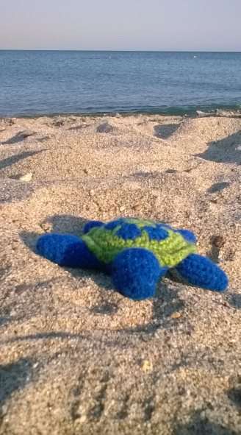[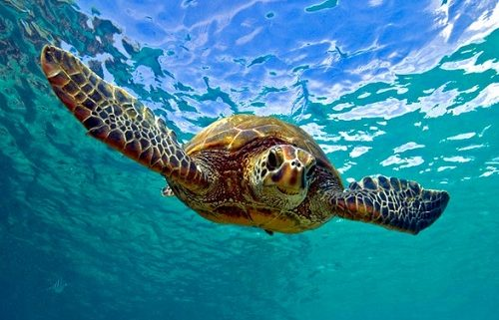](https://www.resortvacationproperties.com/guest-spotlight-sea-turtles/)

**Curriculum Topics**

We Plough the Fields and Scatter - Autumn 1

I’ll Huff and I’ll Puff! – Autumn 2

Amazing Animals - Spring 1

The Lighthouse Keeper’s Lunch - Spring 2

Australia – Summer 1 + 2

**Reading Books**

The reading books your child is given to bring home are levelled. However in Turtles Class the children are also encouraged to borrow books which interest them from our class library. They will choose these and return them when they have been read.

When your child reads their levelled reading book at home could you please write the numbers of the pages they read in their reading record along with how they read, if they enjoyed it and any other observations you wish to note. The reading of other books could also be noted.

We also have a parent reader book box. This contains books that the children are unable to read but would like to have read to them. This is brought to the gate every Monday after school for the children to choose a book with their parent. These are returned to the box when they have been read.

Miss Myers

Mrs McCann

Miss Eggleston

Mrs Kambouris

**Tiny Turtle**

Tiny Turtle will be sent home on Fridays, with his record book.

We would like your child to read to him and then complete his book with what they think Tiny Turtle enjoyed listening to.

**Turtles Classroom Charter**

Please help your child achieve our goals on our Classroom Charter.

**Uniforms**

Please label all items of uniform to assist your child to find their belongings easily.

**Contacts**

Mrs Kambouris

[g.kambouris@poultonstchadsce.lancs.sch.uk](mailto:g.kambouris@poultonstchadsce.lancs.sch.uk)

Emails answered within 48 hours during term time.

**Poulton St. Chad’s CofE Primary School** 01253 883639

**Welcome to Turtles Class!** Year 1 / Year 2

**Urgent communication**

For more urgent messages please call the bursar on 01253 883639 or email ([bursar@poultonstchadsce.lancs.sch.uk](mailto:bursar@poultonstchadsce.lancs.sch.uk)) or contact Mrs Potter ([head@poultonstchadsce.lancs.sch.uk](mailto:head@poultonstchadsce.lancs.sch.uk))