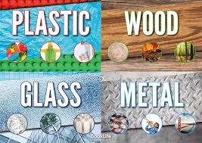
Turtles Homework Autumn Term 2

This half term’s topic is ‘I’ll Huff and I’ll Puff’, the aim of this learning is to give pupils an understanding of different types of materials and their uses. We will be looking at types of homes around the world and the materials that they are made of.

Please help your child to complete one or more of the following tasks:
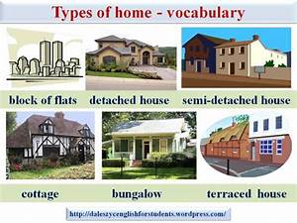
- Take pictures of different types of homes when you are out, perhaps you could print them and label them with what type of home they are and the material they are made out of.

- Investigate one type of material on the internet. You could answer the following questions;
Is it a natural material?
Is it flexible? (Can you bend it?)
Is it waterproof? (Does water pass through it?)
Is it easy to break or tear it?

- Collect items in your house together that are made of the same material. Perhaps you could take a picture of them and bring into class.

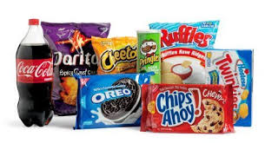
- Draw something made out of wood, something made out of metal, something made out of plastic and something made out of glass.

- When you are at the supermarket see how many different materials are used to package our food and drinks? Perhaps you could use a supermarket leaflet to make a collage of these.
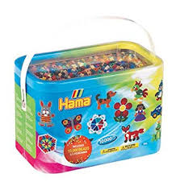
- You could use plastic Hama beads, air drying clay, or paper mache to make something to bring into school. You could explain how you created a new form using plasic, clay or paper.
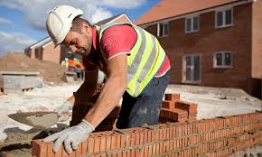
- Do you know anyone who knows how to make things?
You could interview them. What material do they use? Do they use heat?
Do they use glue? Can what they make stay outside? Why/why not? Can what they make be broken easily?

