[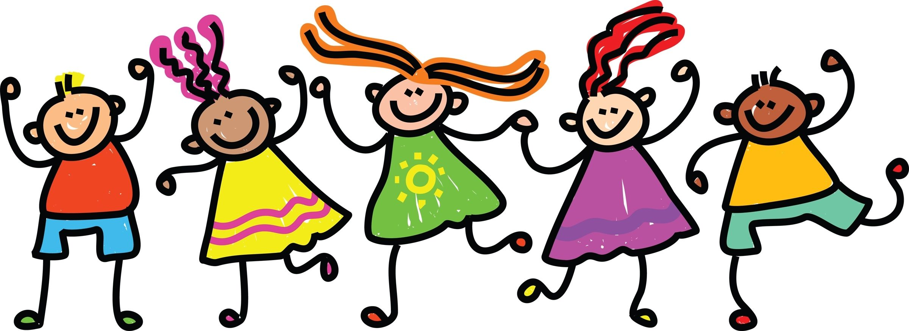](https://www.google.com/url?sa=i&rct=j&q=&esrc=s&source=images&cd=&cad=rja&uact=8&ved=2ahUKEwj9p5LGlqXdAhWKC8AKHaimDykQjRx6BAgBEAU&url=https://www.pinterest.com/pin/522206519277914896/&psig=AOvVaw0lS3mX6AT9ZOSa4PZNEqc6&ust=1536281984939070)

**The following is what is needed each day**

**Mondays**

Bring book bags - reading books checked and changed

Celebration Worship - bring certificates / medals /trophies

Spelling test - new spellings are also given out

Bring Tiny Turtle back to school

**Tuesdays**

Bring PE Kits. Please ensure hair is tied up and earrings are removed.

**Wednesdays**  Bring book bags - reading books checked and changed

**Thursdays**

Bring PE Kits. Please ensure hair is tied up and earrings are removed. Year 2 swimming.

**Fridays**  Bring book bags - reading books checked and changed Tiny Turtle is given out

**Information about Turtles Class on our webpage**

<https://www.poultonstchadsce.lancs.sch.uk> /turtles-year-1-year-2/

**School App**

This half term the school app will be launched, we will send out a letter with all the details. Please sign up to this school app as much of our communication will be through this.

**Homework**

Please find our homework pick and mix menu on our class website page every half term.

**Own belongings**

Please do not allow your child to bring toys, balls or writing equipment into school.

**Water Bottles**

The children have constant access to a fresh water supply. Please provide your child with a clearly labelled sports top bottle or other closed drinking bottle. Your child is allowed to drink freely throughout the day as a means of keeping them hydrated. Your child may need two bottles if they have a packed lunch, one for class and one for their lunch. Juice is not allowed in class.

|  |  |  |  |  |  |  |  |  |  |  |
| --- | --- | --- | --- | --- | --- | --- | --- | --- | --- | --- |
|  | **8:45- 9:05** | **9:05-9:25** | **9:25-10:25** | **10:25-10:40** | **10:45-11:00** | **11:00-12:00** | **12:00-1:00** | **1:00-2:10** | **2:10-2:25** | **2:25-3:25** |
| **MON** | Registration  and  individual task time | Celebration  Worship | Spellings/ English | Break | Phonics | Maths | Lunch | Topic | Break | Art / DT |
| **TUE** | Clergy  Worship | PE | Break | Phonics | Maths | Lunch | RE | Break | English |
| **WED** | Worship | English | Break | Phonics | Science | Lunch | IT | Break | Maths |
| **THUR** | Prayer and  Praise | English | Break | Phonics | Maths | Lunch | PE | Break | Music |
| **FRI** |  | Worship | English /SPAG | Break | Phonics | Maths | Lunch | Guided Reading and PHSE | Break | Handwriting Golden time, and Story time |
| Mrs Kambouris Mrs Shrewsbury Mr Irvine | | | | | | | | | | |

**Turtles Class Weekly Timetable**

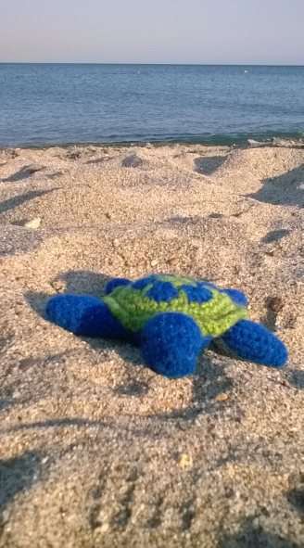[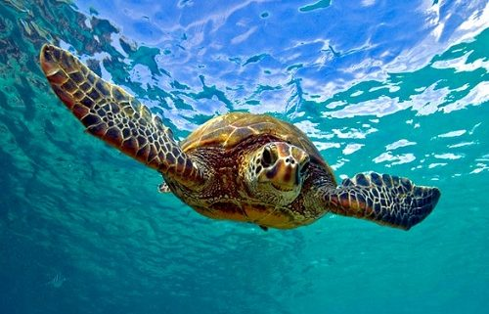](https://www.resortvacationproperties.com/guest-spotlight-sea-turtles/)

Uniforms

Please label all items of uniform to assist your child to find their belongings easily.

**Poulton St. Chad’s CofE Primary School** 01253 883639

Mrs Kambouris

Mrs Shrewsbury

**Welcome to Turtles Class!** Year 1 / Year 2

**Contacts**

Mrs Kambouris

[g.kambouris@poultonstchadsce.lancs.sch.uk](mailto:g.kambouris@poultonstchadsce.lancs.sch.uk)

Mrs Shrewsbury [s.shrewsbury@poultonstchadsce.lancs.sch.uk](mailto:s.shrewsbury@poultonstchadsce.lancs.sch.uk)

Emails answered within 48 hours during termtime.

**Tiny Turtle**

Tiny Turtle will be sent home on Fridays, with his record book.

We would like your child to read to him and then complete his book with what they think Tiny Turtle enjoyed listening to.

**Urgent communication**

For more urgent messages please call the bursar on 01253 883639 or email ([bursar@poultonstchadsce.lancs.sch.uk](mailto:bursar@poultonstchadsce.lancs.sch.uk)) or contact Mrs Potter ([head@poultonstchadsce.lancs.sch.uk](mailto:head@poultonstchadsce.lancs.sch.uk))

Turtles Classroom Charter

Please help your child achieve our goals on our Classroom Charter.

Curriculum Topics

We Plough the Fields and Scatter - Autumn 1

I’ll Huff and I’ll Puff! – Autumn 2

Amazing Animals - Spring 1

The Lighthouse Keeper’s Lunch - Spring 2

Australia – Summer 1 + 2

**Reading Books**

The reading books your child is given to bring home are levelled. However in Turtles Class the children are also encouraged to borrow books which interest them from our class library.

When your child reads their reading book at home could you please write the numbers of the pages they read in their reading record along with how they read, if they enjoyed it and any other observations you wish to note. The reading of other books could also be noted.