Poulton St Chad’s CE Primary School
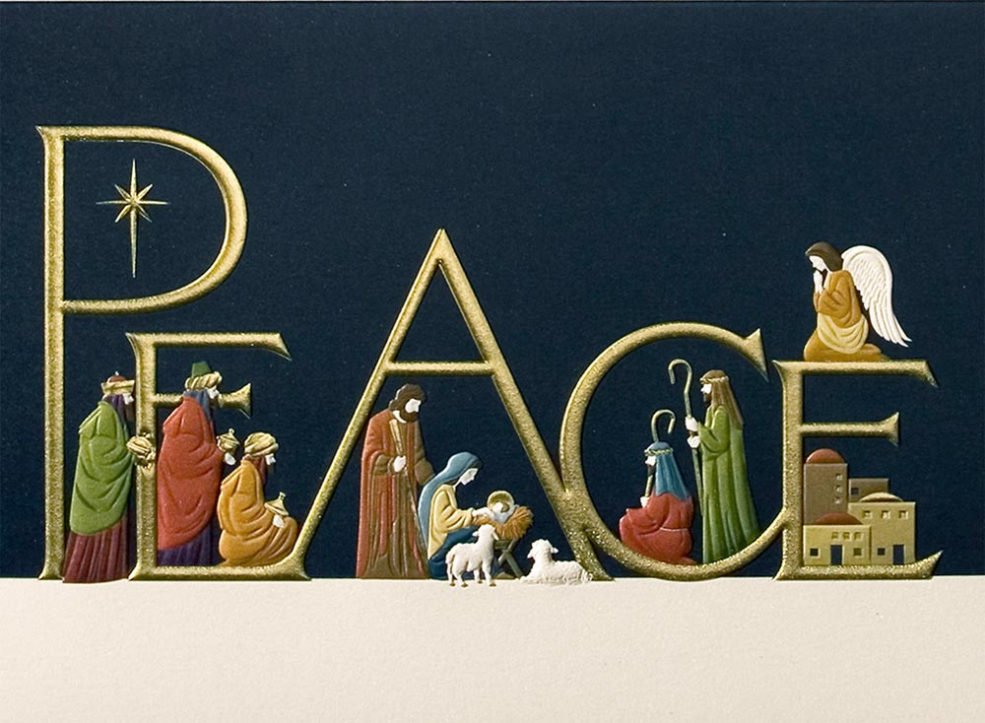

Christmas Song Sheet

Away In a Manger

Away in a manger, no crib for a bed,
The little Lord Jesus laid down his sweet head.
The stars in the bright sky looked down where he lay,
The little Lord Jesus asleep in the hay.

The cattle are lowing the baby awakes
But little Lord Jesus no crying He makes.
I love you Lord Jesus; look down from the sky
And stay by my side until morning is nigh.

Be near me Lord Jesus I ask you to stay
Close by me for ever, and love me, I pray.
Bless all the dear children in Your tender care,
And fit us for heaven, to live with You there.

In The Bleak Midwinter

In the bleak midwinter, frosty wind made moan,
Earth stood hard as iron, water like a stone;
Snow had fallen, snow on snow, snow on snow,
In the bleak midwinter, long ago.

Our God, heaven cannot hold Him, nor earth sustain;
Heaven and earth shall flee away when He comes to reign.
In the bleak midwinter a stable place sufficed
The Lord God Almighty, Jesus Christ.

Enough for Him, whom cherubim, worship night and day,
Swaddling clothes and milk, and a mangerful of hay;
Enough for Him, Whom angels fall before,
The ox and lamb and camel which adore.

Angels and archangels may have gathered there,
Cherubim and seraphim thronged the air;
But His mother only, in her maiden bliss,
Worshipped the beloved with a kiss.

What can I give Him, poor as I am?
If I were a shepherd, I would bring a lamb;
If I were a Wise Man, I would do my part;
Yet what I can I give Him... give my heart.

It Was On a Starry Night

It was on a starry night, when the hills were bright
Earth lay sleeping, sleeping calm and still.
Then in a cattle shed, in a manger bed
a boy was born, king of all the world.

And all the angels sang for him,
the bells of heaven rang for him
for a boy was born, king of all the world.
And all the angels sang for him,
the bells of heaven rang for him
for a boy was born, king of all the world.

Soon the shepherds came that way where the baby lay
and were kneeling, kneeling by his side.
And their hearts believed again for the peace of men,
for a boy was born, king of all the world.
Chorus

O Little Town of Bethlehem

O little town of Bethlehem,
How still we see thee lie!
Above thy deep and dreamless sleep
The silent stars go by.
Yet in the dark streets shineth
The everlasting Light;
The hopes and fears of all the years
Are met in thee tonight.

O morning stars, together
Proclaim the holy birth, a
And praises sing to God the King,
And peace to men on earth.
For Christ is born of Mary;
And, gathered all above,
While mortals sleep, the angels keep
Their watch of wondering love.

How silently, how silently,
The wondrous gift is given!
So God imparts to human hearts
The blessings of His heaven.
No ear may hear His coming;
But in this world of sin,
Where meek souls will receive Him, still
The dear Christ enters in.

O holy Child of Bethlehem,
Descend to us, we pray;
Cast out our sin, and enter in,
Be born in us today.
We hear the Christmas angels
The great glad tidings tell:
O come to us, abide with us,
Our Lord Emmanuel.

Silent Night

Silent night, holy night
All is calm, all is bright
Round yon Virgin Mother and Child
Holy Infant so tender and mild
Sleep in heavenly peace (2x)

Sh-tille nact, high-lig-er nact,
Al-es sh-larft, ine-some vact.
Nor das trout-er hock-high-lig-er par.
Holder narb im lock-i-gen har,
Sh-larf in him-lish-er rooh, (x2)

Silent night, holy night
Al-es sh-larft, ine-some vact.
Round you Virgin, mother and child
Holder narb im lock-i-gen har,
Sleep in heavenly peace,
Sh-larf in him-lish-er rooh.

Winter Wonderland

Sleigh bells ring are you listening
in the lane snow is glistening
A beautiful sight we're happy tonight
walking in a winter wonderland.

Gone away is the bluebird
here to stay is a new bird
He sings a love song as we go along
walking in a winter wonderland.

In the meadow we can build a snowman
Then pretend that he is Parson Brown
He'll say: Are you married?
we'll say: No man but you can do the job
when you're in town.

Later on we'll conspire
as we dream by the fire
To face unafraid the plans that we've made
walking in a winter wonderland.

INSTRUMENTAL

In the meadow we can build a snowman
and pretend that he's a circus clown
We'll have lots of fun with mister snowman
until the other kids knock him down.

When it snows ain't it thrilling
Though your nose gets a chilling
We'll frolic and play the Eskimo way
walking in a winter wonderland.

To face unafraid the plans that we've made
walking in a winter wonderland.

Carol of the Bells

Hark! how the bells
Sweet silver bells
All seem to say,
"Throw cares away."
Christmas is here
Bringing good cheer
To young and old
Meek and the bold

Ding, dong, ding, dong
That is their song
With joyful ring
All caroling
One seems to hear
Words of good cheer
From ev'rywhere
Filling the air

Oh how they pound,
Raising the sound,
O'er hill and dale,
Telling their tale,
Gaily they ring
While people sing
Songs of good cheer
Christmas is here
Merry, merry, merry, merry Christmas
Merry, merry, merry, merry Christmas

On, on they send
On without end
Their joyful tone
To ev'ry home

[Repeat from the beginning]

Ding, dong, ding, dong. (x4)

(Slower) Ding, dong, ding dong.

Christmas Hallelujah

I've heard about this baby boy
Who's come to earth to bring us joy
And I just want to sing this song to you
It goes like this, the fourth, the fifth
The minor fall, the major lift
With every breath I'm singing Hallelujah
Hallelujah
A couple came to Bethlehem
Expecting child, they searched the inn
To find a place for You were coming soon
There was no room for them to stay
So in a manger filled with hay
God's only Son was born, oh Hallelujah
Hallelujah
The shepherds left their flocks by night
To see this baby wrapped in light
A host of angels led them all to You
It was just as the angels said
You'll find Him in a manger bed
Immanuel and Saviour, Hallelujah
Hallelujah
A star shown bright up in the east
To Bethlehem, the wisemen three
Came many miles and journeyed long for You
And to the place at which You were
Their frankincense and gold and myrrh
They gave to You and cried out Hallelujah
Hallelujah
I know You came to rescue me
This baby boy would grow to be
A man and one day die for me and you
My sins would drive the nails in You
That rugged cross was my cross, too
Still every breath You drew was Hallelujah
Hallelujah

