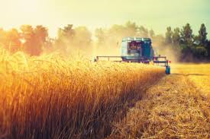
Turtles Homework Autumn Term 1

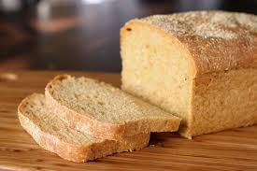
This half term’s topic is ‘We sow the seeds and scatter’, the aim of this learning is to give pupils an understanding of what harvest is and how it is celebrated, where our food comes from and how it reaches our shops.

Please help your child to complete one or more of the following tasks:

- Using a supermarket leaflet create a collage of food that you like.

- Bring in a photograph of food growing.

- Visit a garden centre. Can you spot the plants that provide food?
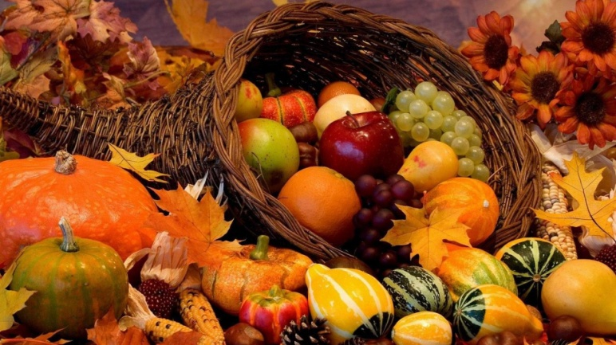
- Look at the fruit labels of the fruit you have bought this week. Which fruit has come from the place furthest away from Poulton?

- Draw a vegetable or fruit that grows underground, on a plant and on a tree.

- Talk to someone who grows fruit or vegetables

- Plant a seed from a piece of fruit, bring in a picture of you with the plant if it grows.
- Research your favourite food. What are its ingredients? Could you make a poster about it?

